(Approx. 603 words)

If You YouTube... Part 2
Ron Sherwood, Member
East-Central Ohio Technology Users Club
https://ecotu.club/
newsletter ** ecotu.club

YouTube content, is it treasure or trash? You make that decision. But, if you view YouTube videos, here is an introduction to some of the basic controls that you may find helpful. Let’s start with the basic playback menu at the video’s bottom.
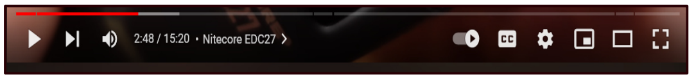
At the far left is the play-pause control. This image appears as an arrow or triangle on its side because the video is paused. Click on the arrow, the video starts playing, and the arrow changes to two parallel bars. These symbols should look familiar since they are used on most audio and video playback devices.

Tapping the space bar, clicking on the video, or pressing the letter “k” will also stop and start playback. The next icon, the arrow with a vertical bar, another icon used on most playback devices, jumps to the end of the current playback and starts a new video.

Next on the control bar is the volume control. Again, the symbol may be similar to other audio-video devices. Placing the cursor over the “speaker” image brings up a slider control used to increase (slide to the right) or decrease (slide to the left) playback volume. This control differs from the Windows volume control, which affects the entire system. To quickly mute a video, click on the speaker or slide the control all the way left. An “X” will appear over the speaker when playback is muted.

The numbers to the right of the speaker indicate the current playback position in minutes and seconds and the total time for the video. For example, this video is at the 2-minute 48-second position of a 15-minute 20-second video. “Nitecore EDC27 is the title of this presentation. The greater than character (>) opens a list of chapters if the video is set up with them.

Skipping to the right, the next control turns Autoplay on or off. In the image above, with the button to the right, Autoplay is on. Moving the slider to the left turns off Autoplay. With Autoplay on, playback will go to a new video and start playing it when the current selection ends.

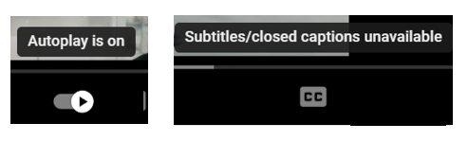
Moving to the right, the CC icon turns closed captioning on and off. Generally, it works well, but I have seen some strange words pop up in the caption dialog. Tapping “c” also opens captioning. Not all videos have the closed caption option.

The Settings gear lets you choose Annotations, Playback speed, and Video Quality. Next, Clicking on the open square of the screen. YouTube calls this “Miniplayer.” Again, we have a one-key shortcut. This time it’s the “I” key. The shortcut key is a toggle: opening the picture-in-picture with a press, then reverting to the standard view with another touch of the “I” key. The next icon, an open rectangle, is the “theater” mode. The standard view places a list of additional videos to the right of the one playing. Theater view toggles this list on and off. The shortcut key “t” does the same. The four corner brackets that form an “open square” is the “full screen” icon. Click it to enlarge the current video to full screen. Pressing Escape returns to the standard view. The “f” key is a toggle for full screen and returns to the normal view.
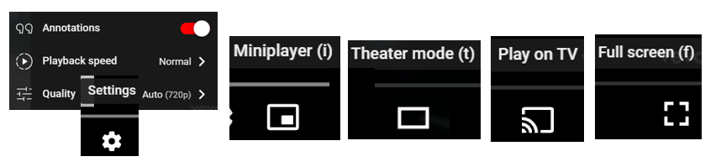
We touched on the basic controls for viewing YouTube videos, but the site has many other features, such as sharing, clipping, saving, and transcripts. I encourage you to explore these features if you are a YouTube regular or just an occasional user.

